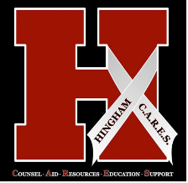
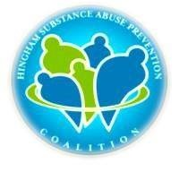
Hingham Substance Abuse Prevention Coalition

Meeting Agenda

September 21, 2016 5pm

- Call to order- Fran Donlan
- Welcome to current & new members – Fran Donlan
- Approval of minutes from last meeting- Kathy Crowley
- Short documentary, “Marijuana, Then and Now” with Q& A
- Guest Speaker: Detective John Marquardt , Hingham Police Department
“What’s Happening in Hingham”

- Updates: Action Updates - Fran Donlan & Chief Olsson
- Formed A Steering Committee comprised of: Chief Glenn Olsson, Dot Galo, Lori McCarthy, Kathy Crowley, Liz Bienfang, Megan Broderick, Paul Gannon, Fran Donlan
- Outreach and Education: Participated in Family Fun Day
- Outreach and Education: Presentation to Hingham Rotary Club
- Created a new Hingham C.A.R.E.S. logo and banner
- Police Dept. new procedure
- Nalaxone initiation
- High School Sports Night
- Facebook and website progress
Action Items In Progress:
a. Working with HCAM to deliver PSAs
b. Potential partnership with Middle School and The Brain Drain
c. Booked Hingham Library for Hidden In Plain Sight, Nov. 30th
d. Possible joint effort with Cohasset, Film by Wahlburg,” If Only”
e. Continuing to sign up Sector Representatives for DFC Grant
Upcoming Events:
6th Annual Prevention of Underage Drinking and Substance Use Conference
Wednesday, September 28, 2016
- Date and Agenda for next Coalition Meeting- Adjourn by 6:30
*Meetings are held in the School Department Conference Room, @ 210 Central Street

